**Paidy payment processing**

Version<22.1.1>



# Table of contents

Details

[Table of contents 2](#_Toc131673229)

[1. Summary 4](#_Toc131673230)

[2. Component summary 5](#_Toc131673231)

[2-1. Features overview 5](#_Toc131673232)

[2-2. Restrictions and limitations 5](#_Toc131673233)

[2.3. Use cases 6](#_Toc131673234)

[2-3-1. Standard payments 6](#_Toc131673235)

[2-3-2. Subscription payments 9](#_Toc131673236)

[2-4. Privacy when paying 13](#_Toc131673237)

[3. Implementation guide 14](#_Toc131673238)

[3-1. Uploading cartridges (UX Studio) 14](#_Toc131673239)

[3-2．BusinessManager setup 14](#_Toc131673240)

[3-2-1. Cartridge assignment 14](#_Toc131673241)

[3-2-2. Importing metadata 15](#_Toc131673242)

[3-3. Modifying cartridges on the merchant 20](#_Toc131673243)

[3-3-1. CheckoutJS installation 20](#_Toc131673244)

[3-3-2. Controlling purchase confirmation buttons 22](#_Toc131673245)

[3-3-3. Modifying resource files 23](#_Toc131673246)

[3-4. Modifying cartridges on the merchant 23](#_Toc131673247)

[3-4-1. Modifying COBillingjs 23](#_Toc131673248)

[3-4-2. COPlaceOrder.js modifications 25](#_Toc131673249)

[3-4-3. COSummary.js modifications 27](#_Toc131673250)

[3-4-4. Modifying to package.json on the JS controller cartridge at the merchant 28](#_Toc131673251)

[3-4-5. Modifying package.json on the int\_paidy\_controllers cartridge 28](#_Toc131673252)

[3-5. Advice 28](#_Toc131673253)

[4. Cartridge deployment testing at merchant 30](#_Toc131673254)

[4-1. Before beginning a test 30](#_Toc131673255)

[4-1-1. Paidy merchant management screen 30](#_Toc131673256)

[4-1-2.Commerce Cloud Business Manager 31](#_Toc131673257)

[4-2.PaidyCheckout test data 31](#_Toc131673258)

[4-3. Browser compatibility 32](#_Toc131673259)

[4-4. Test cases 32](#_Toc131673260)

[4-4-1. Paidy standard payments 32](#_Toc131673261)

[4-4-2. Paidy subscription payments 33](#_Toc131673262)

[5. Webhook usage examples 34](#_Toc131673263)

[5-1. Webhook usage 34](#_Toc131673264)

[5-2. Detecting inconsistent payments 34](#_Toc131673265)

[5-3. Handling inconsistencies 35](#_Toc131673266)

[5-3-1. Processing example 1 35](#_Toc131673267)

[5-3-2. Processing example 2 38](#_Toc131673268)

[5-4. Webhook settings 38](#_Toc131673269)

[6. What to do when the service is down 39](#_Toc131673270)

[7. Revision history 39](#_Toc131673271)

# 1. Summary

Cartridges allow a Commerce Cloud store to make use of Paidy payments.

The developer must follow this text to install the cartridges and set them up on the online store.

Because Paidy allows for creating test payments by making use of a test API key, the user can test the settings before switching over to a live environment. For details on data needed for testing, see 4-1. Before beginning a test.

Three cartridges must be implemented in order to begin using Paidy payments.

- int\_paidy is the core cartridge that enables use of Paidy payments on the store.

- int\_paidy\_controllers is a cartridge that enables support of Paidy payments on a JSController site.

# 2. Component summary

## 2-1. Features overview

The process flow for Paidy is explained in the diagram below.

Paidy cartridges correspond to point 1-6 in this workflow.

In step 1-6, the results of authentication with Paidy are saved on the site.

## 2-2. Restrictions and limitations

- Only a “creation” process is in place for payment. Capture, Refund, Update, and Close must be implemented by the merchant.

- For first-time subscription payments, Commerce Cloud runs a creation process.

　Subsequent payments must be configured at the merchant, but the payment process can be implemented by executing the functions found in the Paidy cartridge.

- Subscription payments are designed to only work when the user is logged in.

- Confirm notifications from the Webhook on OMS; if the payment process results are incorrect, you can choose to set the order status to shippable in SFCC, or cancel the payment on Paidy. For details, please see [5. Webhook usage examples](#_5.運用案).

- This cartridge can only be used on Japanese language sites. (language: Japanese; currency: JPY)

## 2.3. Use cases

### 2-3-1. Standard payments

　Paidy Checkout launches when a user clicks a payment purchase button on a site.

　Consumers enter the requisite information and make a Paidy payment.

　If the payment is successful, the process transitions to the product purchase confirmation screen.

- Payment flow

Select Paidy standard payments when selecting a payment method when checking out and proceed to confirming the order.

The Paidy Checkout popup appears.

The requisite information is filled in and Paidy payment is processed.

If the payment succeeds, the order is complete.

Order data created on Commerce Cloud

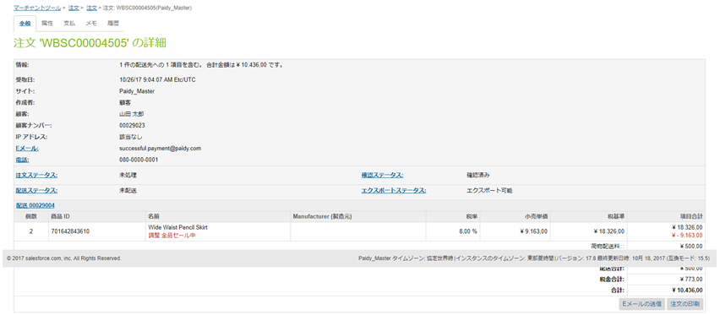

Payment data created on Paidy

If the payment fails, Paidy Checkout displays a payment error message and order failure data is created on Commerce Cloud.

Payment data will not be created on Paidy.

\*Note that if the top-right X button is clicked on the popup, order failure data is created. Payment data will not be created on Paidy.

Order data created on Commerce Cloud (order failure)

### 2-3-2. Subscription payments

　 Only usable by logged in users.

When transitioning to a screen to confirm a purchase of products on the site, a check is performed to see if the consumer has a token.

　When clicking on the order confirmation button for a first time purchase, there is no token, so Paidy Checkout launches. Consumers enter the requisite information and authenticate with Paidy. If the authentication completes correctly, a token is issued and is assigned to the consumer.

Once a token has been assigned or if the user has a token, the token data is used for Paidy payment.

- Payment flow

Select Paidy subscription payments when selecting a payment method when checking out and proceed to confirming the order.

An order confirmation screen is displayed and the order is confirmed.

The Paidy Checkout popup appears (only the first time).

Enter the requisite information on Paidy Checkout and a token is issued.

\*If the popup is closed during the process by the user clicking the X button on the top right, the popup will no longer display, but a token can be reissued and the payment processed.

After issuing a token, the process moves to payment processing. If the payment succeeds, we transition to the order confirmation screen.

Order data created on Commerce Cloud

Payment data created on Paidy

If payment fails, a payment error will be displayed on the order confirmation page and order failure data is created on Commerce Cloud.

Payment data will not be created on Paidy.

Order data created on Commerce Cloud (order failure)

## 2-4. Privacy when paying

Paidy payment authentication requires entering a telephone number and e-mail address, but these are not saved on Commerce Cloud.

However, information entered upon registration and shipment and billing details are saved on Commerce Cloud.

# 3. Implementation guide

## 3-1. Uploading cartridges (UX Studio)

The cartridge is uploaded to Commerce Cloud.

- int\_paidy

- int\_paidy\_controllers (JSController sites)

The Paidy cartridge can be used on SiteGenesis-based JSController sites.

Use Commerce Cloud UX-studio to upload the int\_paidy and int\_paidy\_controllers cartridges to Commerce Cloud.

## 3-2．BusinessManager setup

Paidy payment settings are configured on the Commerce Cloud management screen (Business Manager).

### 3-2-1. Cartridge assignment

A Paidy cartridge is assigned to the site.

Management > Sites > Site Management > Sites Under Management: Settings

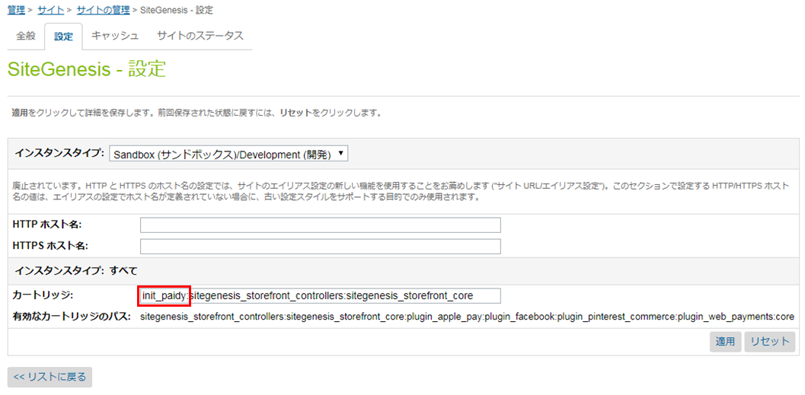

- JSController sites

int\_paidy\_controllers:int\_paidy: merchant cartridge

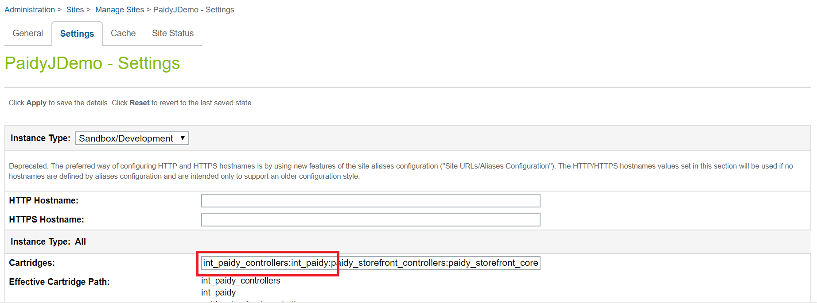

### 3-2-2. Importing metadata

meta\_data\_22.1.0\_sg.zip is provided in the package.

By importing this zip file, you can add services, add payment methods / payment processors, change system objects and custom objects to use Paidy payment. Details will be described later.

Administration > Site Development > Site Import & Export

Click [Choose File].

Select meta\_data\_22.1.0\_sg.zip in the package and click the [Upload] button.

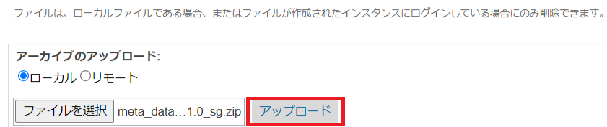

After uploading the zip file, check meta\_data\_22.1.0\_sg.zip and click [Import].

Click [OK].



-Configuration when importing service metadata

Describes the service configuration when importing metadata.

Note that for services added after import

Please do not change the information described.

<Service Credentials>

Name: paidy.http.payment

URL: https://api.paidy.com

<Service Profiles>

Name: paidy.api.prof

<Services>

Name: paidy.api.payment

Type: HTTP

Enabled: check on

Service Mode: Live

Profile: paidy.api.prof

認証Credentials: paidy.http.payment

· Payment method · Configuration when importing payment processor metadata

Describes the payment method and payment processor configuration when metadata is imported.

As a point of caution, for payment methods and payment processors added after import

Please do not change the information described.

<Payment Processors >

ID: PAIDY\_STANDARD

<Payment Processors >

ID: PAIDY\_SUBSCRIPTION

<Payment Methods >

ID: PAIDY\_STANDARD

Name: あと払い（ペイディ）

Enabled: Yes

<Payment Methods >

ID：PAIDY\_SUBSCRIPTION

Name: あと払い（ペイディ）※定期購入

Enabled: Yes

- Object layout for metadata importing

Here we include instructions on the layout of objects when importing metadata.

One word of caution is that system and custom objects added after importing should not be modified.

<Order>

Management > Site Development > System Object Types> Order - Attribute Definitions

System objects: Order is an object that corresponds to order data

Order is given the below definitions as custom attributes.

paidyPaymentId: saves the ID issued when making a Paidy payment.

paidyToken: saves the token value used when using subscription payments.

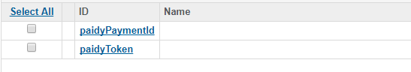

<Site Preferences>

Management > Site Development > System Object Types > Site Preferences > Attribute Definitions

System object: Site Preferences is an object that corresponds to site settings.

The below is defined as a custom attribute in Site Preferences.

paidy\_api\_key: public key data used to connect to the Paidy API.

　　　　　　　 This can be confirmed on the Paidy merchant management screen.

　　　　　　　For a test, save the public key used for testing purposes.

paidy\_enabled: Set to use or not use Paidy cartridges.

If turn it off, paidy payments will not be available as a payment method.

- Paidy merchant management screen (details found in section 4-1-1)

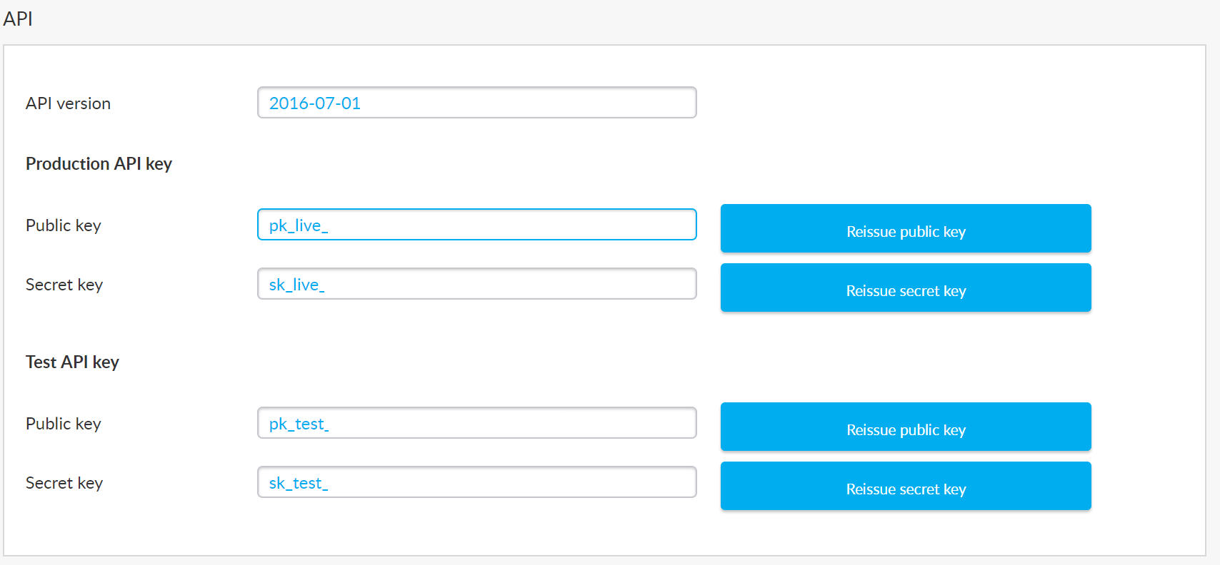

paidy\_logo\_url: the URL of a logo image to be displayed on the Paidy Checkout application.

　　　　　　　 If nothing is set, the Paidy logo will be shown.

paidy\_secret\_key: secret key data used to connect to the Paidy API.

　　　　　　　　 This can be confirmed on the Paidy merchant management screen.

　　　　　　　　 When testing, save the secret key used for testing purposes.

paidy\_service\_name: key data used to call the information for communicating with Paidy as registered in BM.

　　　　　　　　　　This is fixed to paidy.api.payment.

paidy\_store\_name: the shop name displayed on Paidy Checkout application headers, MyPaidy, and the merchant dashboard.

paidy\_token\_description (optional): specifies descriptions of tokens defined by the merchant.

<Customer Profile>

Management > Site Development > System Object Types > Customer Profile > Attribute Definitions

System object: Customer Profile is an object relating to customer data.

The below is defined as a custom attribute on the Customer Profile.

paidyToken: token data used for subscription payments. Saved when issuing a token.

C:\Users\minoru.hotani\AppData\Local\Microsoft\Windows\INetCache\Content.Word\3-2-4メタデータのインポート_08.png

<Custom site environment settings>

Merchant Tools > Site Environment Settings > Custom Site Environment Settings Group

Once metadata is successfully imported, a group with the Paidy ID will be created in the custom environment settings group.

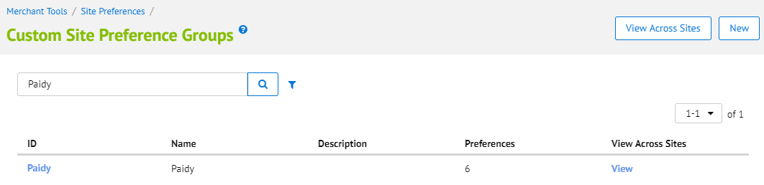

Clicking Paidy displays configuration screens for each value. Enter the requisite information and click the Save button at the top right.

## 3-3. Modifying cartridges on the merchant

### 3-3-1. CheckoutJS installation

In order to call Paidy Checkout and process payment, the Checkout JS script is embedded in the payment page template.

Including this script will call Paidy Checkout.

To embed the template, modify the following file.

- [storefront\_core]\cartridge\templates\default\components\footer\footer\_UI.isml

Add the below after <script src="${URLUtils.staticURL('/js/app.js')}"></script>

...........................

<isscript>

if (!empty(pdict.Basket)) {

var paymentMethods = pdict.Basket.getPaymentInstruments();

var paymentMethod = '';

if (paymentMethods != null && !paymentMethods.isEmpty() ) {

for( var i = 0; i < paymentMethods.length ; i++ ){

if( paymentMethods[i] != null && paymentMethods[i].paymentMethod != "GIFT\_CERTIFICATE" )

paymentMethod = paymentMethods[i].paymentMethod;

}

}

}

</isscript>

<isif condition="${paymentMethod=='PAIDY\_STANDARD'}">

<script type="text/javascript" src="https://apps.paidy.com/"></script>

<script src="${URLUtils.staticURL('js/paidyStandard.js')}"></script>

<iselseif condition="${paymentMethod=='PAIDY\_SUBSCRIPTION'}">

<script type="text/javascript" src="https://apps.paidy.com/"></script>

<script src="${URLUtils.staticURL('js/paidySubscription.js')}"></script>

<iselse/>

<script>

(function(){

var button = $('.submit-order button[type="submit"]');

if(button.length) {

button.prop('disabled', false);

button.removeClass('disabled');

}

}());

</script>

</isif>

...........................

### 3-3-2. Controlling purchase confirmation buttons

When displaying the purchase confirmation screen and before the HTML source code is fully imported, if the confirm purchase button is clicked, the Paidy Checkout popup may fail to function properly.

Therefore, the purchase confirmation button must be styled such that it cannot be clicked when first displayed.

The template implements this as follows.

- [storefront\_core]\cartridge\templates\default\checkout\summary\summary.isml

A button with the button-fancy-large class is also given the disabled class and disabled attribute.

<button class="button-fancy-large disabled" type="submit" name="submit" value="${Resource.msg('global.submitorder','locale',null)}" disabled>

The tag is added immediately after the close tag on the <form action="${URLUtils.https('COSummary-Submit')}" method="post" class="submit-order"> add tags immediately after the form tag.

<input type="hidden" name="selected\_payment\_method" value="${pdict.CurrentForms.billing.paymentMethods.selectedPaymentMethodID.value}"/>

The above form tag also includes the submit-order class; this class should be left in and not deleted.

The purchase confirmation button will now only be clickable when Paidy Checkout is ready.

### 3-3-3. Modifying resource files

Using Paidy payments requires including URL and timeout information in a configuration file called a resource file.

- [storefront\_core]\cartridge\scripts\util\Resource.ds

　Add the below at the end of the urls section of ResourceHelper.getUrls

...........................

getPaidyStandardPaidyConfig : URLUtils.https("PaidyStandard-GetPaidyConfig").toString(),

doPaidyStandardCOSummarySubmit: URLUtils.https("COSummary-Submit").toString(),

doPaidyStandardFailOrder : URLUtils.https("PaidyStandard-FailOrder").toString(),

doPaidyStandardPlaceOrder : URLUtils.https("PaidyStandard-PlaceOrder").toString(),

getPaidyStandardOrderToken : URLUtils.https("PaidyStandard-GetOrderToken").toString(),

getPaidySubscriptionConfig : URLUtils.url(PaidySubscription-GetPaidyConfig').toString(),

setPaidySubscriptionToken : URLUtils.url(PaidySubscription -SetPaidyToken').toString()

...........................

## 

## 3-4. Modifying cartridges on the merchant

### 3-4-1. Modifying COBillingjs

A routine is added to clear the fields if the payment method is changed from credit card or BML to Paidy.

...........................

function resetPaymentForms() {

var cart = app.getModel('Cart').get();

var status = Transaction.wrap(function () {

if (app.getForm('billing').object.paymentMethods.selectedPaymentMethodID.value.equals('PayPal')) {

app.getForm('billing').object.paymentMethods.creditCard.clearFormElement();

app.getForm('billing').object.paymentMethods.bml.clearFormElement();

cart.removePaymentInstruments(cart.getPaymentInstruments(PaymentInstrument.METHOD\_CREDIT\_CARD));

cart.removePaymentInstruments(cart.getPaymentInstruments(PaymentInstrument.METHOD\_BML));

cart.removePaymentInstruments(cart.getPaymentInstruments('PAIDY\_STANDARD'));

cart.removePaymentInstruments(cart.getPaymentInstruments('PAIDY\_SUBSCRIPTION'));

} else if (app.getForm('billing').object.paymentMethods.selectedPaymentMethodID.value.equals(PaymentInstrument.METHOD\_CREDIT\_CARD)) {

app.getForm('billing').object.paymentMethods.bml.clearFormElement();

cart.removePaymentInstruments(cart.getPaymentInstruments(PaymentInstrument.METHOD\_BML));

cart.removePaymentInstruments(cart.getPaymentInstruments('PayPal'));

cart.removePaymentInstruments(cart.getPaymentInstruments('PAIDY\_STANDARD'));

cart.removePaymentInstruments(cart.getPaymentInstruments('PAIDY\_SUBSCRIPTION'));

} else if (app.getForm('billing').object.paymentMethods.selectedPaymentMethodID.value.equals(PaymentInstrument.METHOD\_BML)) {

app.getForm('billing').object.paymentMethods.creditCard.clearFormElement();

if (!app.getForm('billing').object.paymentMethods.bml.ssn.valid) {

return false;

}

cart.removePaymentInstruments(cart.getPaymentInstruments(PaymentInstrument.METHOD\_CREDIT\_CARD));

cart.removePaymentInstruments(cart.getPaymentInstruments('PayPal'));

cart.removePaymentInstruments(cart.getPaymentInstruments('PAIDY\_STANDARD'));

cart.removePaymentInstruments(cart.getPaymentInstruments('PAIDY\_SUBSCRIPTION'));

} else if (app.getForm('billing').object.paymentMethods.selectedPaymentMethodID.value.equals('PAIDY\_STANDARD')) {

app.getForm('billing').object.paymentMethods.creditCard.clearFormElement();

app.getForm('billing').object.paymentMethods.bml.clearFormElement();

cart.removePaymentInstruments(cart.getPaymentInstruments(PaymentInstrument.METHOD\_CREDIT\_CARD));

cart.removePaymentInstruments(cart.getPaymentInstruments(PaymentInstrument.METHOD\_BML));

cart.removePaymentInstruments(cart.getPaymentInstruments('PayPal'));

cart.removePaymentInstruments(cart.getPaymentInstruments('PAIDY\_SUBSCRIPTION'));

} else if (app.getForm('billing').object.paymentMethods.selectedPaymentMethodID.value.equals('PAIDY\_SUBSCRIPTION')) {

app.getForm('billing').object.paymentMethods.creditCard.clearFormElement();

app.getForm('billing').object.paymentMethods.bml.clearFormElement();

cart.removePaymentInstruments(cart.getPaymentInstruments(PaymentInstrument.METHOD\_CREDIT\_CARD));

cart.removePaymentInstruments(cart.getPaymentInstruments(PaymentInstrument.METHOD\_BML));

cart.removePaymentInstruments(cart.getPaymentInstruments('PayPal'));

cart.removePaymentInstruments(cart.getPaymentInstruments('PAIDY\_STANDARD'));

}

return true;

});

return status;

}

...........................

### 3-4-2. COPlaceOrder.js modifications

When creating an order in Ajax on Paidy, the below is added to suspend the process before executing payment.

...........................

function handlePayments(order) {

(Abbreviated)

} else {

var authorizationResult = PaymentProcessor.authorize(order, paymentInstrument);

if (authorizationResult.not\_supported || authorizationResult.error) {

return {

error: true**,**

**PlaceOrderError: authorizationResult.PlaceOrderError**

};

}

}

}

}

return {};

}

function start() {

(Abbreviated)

var handlePaymentsResult = handlePayments(order);

if (handlePaymentsResult.error) {

return Transaction.wrap(function () {

OrderMgr.failOrder(order);

**if (handlePaymentsResult.PlaceOrderError != null) {**

return {

error : true,

**PlaceOrderError : handlePaymentsResult.PlaceOrderError**

**};**

**} else {**

**return {**

**error : true,**

PlaceOrderError : new Status(Status.ERROR,'confirm.error.technical')

};

**}**

});

} else if (handlePaymentsResult.missingPaymentInfo) {

(Abbreviated)

}

**if (request.httpParameterMap.format.stringValue == 'ajax') {**

**return {**

**Order: order,**

**paidy\_order\_created: true**

**};**

**}**

var orderPlacementStatus = Order.submit(order);

if (!orderPlacementStatus.error) {

clearForms();

}

return orderPlacementStatus;

}

...........................

### 3-4-3. COSummary.js modifications

When creating an order in Ajax on Paidy, the below is added to create a JSON response if the process is suspended before payment is processed.

...........................

function submit() {

var placeOrderResult = app.getController('COPlaceOrder').Start();

if (placeOrderResult.error) {

start({

PlaceOrderError: placeOrderResult.PlaceOrderError

});

} else if (placeOrderResult.order\_created) {

showConfirmation(placeOrderResult.Order);

**} else if (placeOrderResult.paidy\_order\_created) {**

**var paidyCartridge = require('~/package.json').paidyCartridge;**

**var currentForms = session.forms;**

**app**

**.getView({**

**JSONResponse: require(paidyCartridge +**

**'/cartridge/scripts/paidy/standard/authorize').getConfirmationPaidyJSON(**

**currentForms.billing.paymentMethods.selectedPaymentMethodID.value,**

**customer,**

**placeOrderResult.Order**

**)**

**})**

**.render('util/responsejson');**

}

}

...........................

### 3-4-4. Modifying to package.json on the JS controller cartridge at the merchant

Add a reference to the Paidy cartridge to the package.json used on the merchant’s JSController cartridge.

...........................

{

"hooks": "./cartridge/scripts/hooks.json"**,**

**"paidyCartridge": "int\_paidy"**

}

...........................

### 3-4-5. Modifying package.json on the int\_paidy\_controllers cartridge

Change the name of the cartridge called by “controllers” to the name of the JSController cartridge used by the merchant.

...........................

{

"paidyCartridge": "int\_paidy",

"hooks": "./cartridge/scripts/hooks.json",

**"controllers": "paidy\_storefront\_controllers"**

}...........................

## 3-5. Advice

- Notes on use of subscription purchases

　If you followed the steps to add a payment method as indicated in section 3-2-3, by default, you will have two separate entries -- standard payments and subscription payments.

テキスト

If there are means to detect whether subscription payments have been selected when transitioning to the payment selection screen, CSS or other means can be used to restrict the display to only show Paidy next-month payment (convenience store/bank).

- Notes on tokens

Merchant Tools > Clients > Client Management > Client Numbers: All

Tokens can be checked via client data.



If, for some reason, you want to reissue a token, enter a null value in paidyToken and have the consumer purchase another subscription payment.

- Order confirmation e-mails for subscription purchases  
The int\_paidy cartridge is designed such that order confirmation e-mails are sent in the same manner as standard e-mails even for subscription purchases. To customize the e-mail sent, you can modify the int\_paidy cartridge.

- Error message when a subscription payment is rejected  
Please refer to the following wording for the message when a subscription payment is rejected.

------------------------------------------------------

今回の決済は承認されませんでした

申し訳ございませんが、オンラインショップが提供する他の支払方法をご利用ください。

なお、審査結果の詳細につきましては開示できませんのであらかじめご了承ください。

Paidyに関するお問い合わせ

0120-971-918

------------------------------------------------------

# 4. Cartridge deployment testing at merchant

## 4-1. Before beginning a test

### 4-1-1. Paidy merchant management screen

- Confirming the test API key

Check the public and secret keys used for the test API; these will be entered into the custom site environment settings screen.



### 4-1-2.Commerce Cloud Business Manager

- API key settings

From the above settings screen, enter the test API keys you found for paidy\_api\_key and paidy\_secret\_key in section 4-1-1. Paidy merchant management screen.

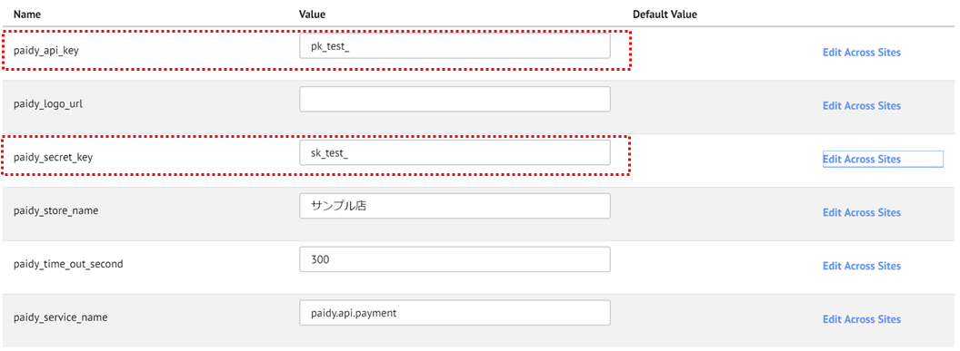

## 4-2.PaidyCheckout test data

- E-mail address and phone number

E-mail address and telephone usable for test cases

|  |  |  |
| --- | --- | --- |
| Test cases | E-mail address | phone number |
| Success | successful.payment@paidy.com | 080-0000-0001 |
| Failure | rejected.payment@paidy.com |

\*Note that the e-mail address and phone number for the above member data and shipping and billing address can differ.

- Authentication number

Enter 8888.

## 4-3. Browser compatibility

This cartridge supports the following OSes and browsers.

|  |  |
| --- | --- |
| Device - OS | Browser |
| PC: Windows | Edge: latest version |
| Chrome: latest version |
| Firefox: latest version |
| PC: MacOS | Chrome: latest version |
| Safari: latest version |
| Smartphone: iOS | iPhone (latest version of iOS), Safari  iPhone (latest version of iOS), Chrome |
| Smartphone: Android | Android 4.4 and later, Chrome |

## 4-4. Test cases

Test cases to run after configuring the cartridge are listed below.

### 4-4-1. Paidy standard payments

Standard payment is tested using a guest and a member.

1. Successful order as guest

- If not logging in and selecting a payment method for Paidy standard payments, the PaidyCheckout popup appears. Entering a successful e-mail address and phone number will display the product purchase confirmation screen.

- The Commerce Cloud order number created on the Paidy merchant site should be displayed as a transaction ID

- The order status for the corresponding order number on Business Manager on Commerce Cloud will be new

2. Order success as member

- After logging in, when selecting a payment method for Paidy standard payments, the PaidyCheckout popup appears. Entering a successful e-mail address and phone number will display the product purchase confirmation screen.

- The Commerce Cloud order number created on the Paidy merchant site should be displayed as a transaction ID

- The order status for the corresponding order number on Business Manager on Commerce Cloud will be new

3. Failed order as guest

- If not logging in and selecting a payment method for Paidy standard payments, the PaidyCheckout popup appears. Entering a failing e-mail address and phone number will display an error message.

- The order status for the corresponding order number on Business Manager on Commerce Cloud will have failed

4. Order failure as member

- After logging in, when selecting a payment method for Paidy standard payments, the PaidyCheckout popup appears. Entering a failing e-mail address and phone number will display an error message.

- The order status for the corresponding order number on Business Manager on Commerce Cloud will have failed

### 4-4-2. Paidy subscription payments

Use of subscription payments always requires logging in. Once the user succeeds at authentication for a subscription payment, the paidyToken containing that member’s data is saved. Subsequent purchases do not display the PaidyCheckout popup. For testing purposes, you may elect to delete the paidyToken from Business Manager on Commerce Cloud in order to display the popup again.

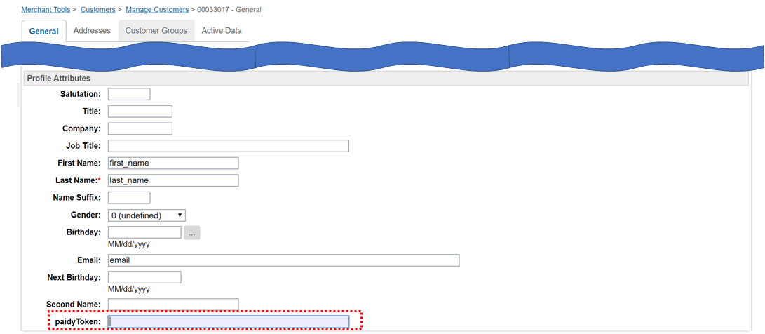

1. Success with no token

- When logging in as a member with no token yet issued and selecting a payment method for Paidy subscription payments, the Confirm Order button is clicked and the PaidyCheckout popup appears. Entering a successful e-mail address and phone number and proceeding to processing the payment will display a product purchase confirmation screen

- The Commerce Cloud order number created on the Paidy merchant site should be displayed as a transaction ID

- The order status for the corresponding order number on Business Manager on Commerce Cloud will be new

2. Failure with no token

- When selecting a payment method for Paidy subscription payments and clicking the Confirm Order button, the PaidyCheckout popup appears. Entering a failing e-mail address and phone number and proceeding to processing the payment will display an error message

- The order status for the corresponding order number on Business Manager on Commerce Cloud will have failed

3. Order success with token

- When logging in as an account that has previously succeeded with a Paidy subscription payment and selecting a payment method for a Paidy subscription payment and clicking the Confirm Order button, a product purchase confirmation screen is displayed

- Because a token exists, the PaidyCheckout popup does not appear

- The Commerce Cloud order number created on the Paidy merchant site should be displayed as a transaction ID

- The order status for the corresponding order number on Business Manager on Commerce Cloud will be new

# 5. Webhook usage examples

## 5-1. Webhook usage

Paidy payments run credit holds for a purchase by means of communication directly between a consumer and Paidy over JavaScript. Therefore, one limitation of the system is that if the consumer bounces or the connection is cut, the e-commerce site may fail to obtain the results of payment confirmation and the stale payment data will remain on Paidy.

In the event of an inconsistency like the above, there are two problems.

1. The shop loses the opportunity to complete the order.

2. If the order does not have to be completed, the consumer has a credit hold placed against their Paidy account.

To accommodate these cases, a Webhook is provided.

The merchant can use the Webhook to detect inconsistent payments.

## 5-2. Detecting inconsistent payments

1. Payment

Payment is made via Commerce Cloud using Paidy. A callback from Paidy’s payment results returns one of the three order statuses below.

- Payment success: New Outputted to the order list. Payment possible status

- Payment failure: Failed Not outputted to the order list. Payment not possible status

- Processing: Created Not outputted to the order list. When in a payment not possible status, updating the payment transitions to a payable status.

2. Webhook

Setting Webhook endpoints on the merchant backend allows for receiving notifications from Paidy of payment completion.

3. Order list

A list of successful orders processed through batch processing on Commerce Cloud is sent as an xml file to the merchant’s backend.

4. Inconsistent payment check processing

Checks for payments where Webhook data (2) is found, but no payment data (3) exists on Commerce Cloud.

## 5-3. Handling inconsistencies

Inconsistent payments that have been detected can be handled as follows, allowing for resolving the above issues.

### 5-3-1. Processing example 1

In this solution, a list of inconsistent/invalid payments is outputted and can be checked by the merchant.

After a check is performed, the necessary steps are taken (approving or cancelling payment).

1. Establishing payment

Use the Order function on Business Manager on Commerce Cloud to update the status.

- General tab

The status of the above three points is changed per below

Order Status: Created→Open

Confirmation Status: Not Confirmed→Confirmed

Export Status:Not Exported→Ready for Export

- Attributes tab

Set the paidyPaymentID that arrived via the Webhook for paidyPaymentId

\*In order to e-mail an order confirmation e-mail as you would with StoreFront, it must be customized, as the format differs (see below).

- Order confirmation e-mail (concept)

■SiteGenesis StoreFront e-mail (normally used e-mail)

E-mails sent from SendMail button on bottom of General tab on BusinessManager > Orders

2. Cancelling payments

Displaying the transaction in question on the Paidy merchant management screen and Canceling it (do not capture and close).

### 5-3-2. Processing example 2

In this example, the system makes a determination and automatically cancels inconsistent payments.

If, after referencing the order data and Webhook data on Commerce Cloud, the payment does not complete on Commerce Cloud, and authorization data is found only on Paidy, the close API is requested and the payment is closed.

https://paidy.com/docs/jp/payments.html#close

## 5-4. Webhook settings

In order to receive notifications from Paidy on the backend, the Webhook URL must be saved to the Paidy merchant management screen settings.

URL: https://merchant.paidy.com

You can enable these settings for a live environment by setting the merchant’s live backend URL in the Webhooks: Live API Key and Old Version API Access Key sections.

In order to check connectivity with test payments before configuring the live environment, set the merchant’s backend test URL in Webhooks: Test API Key.

Paidy merchant management screen

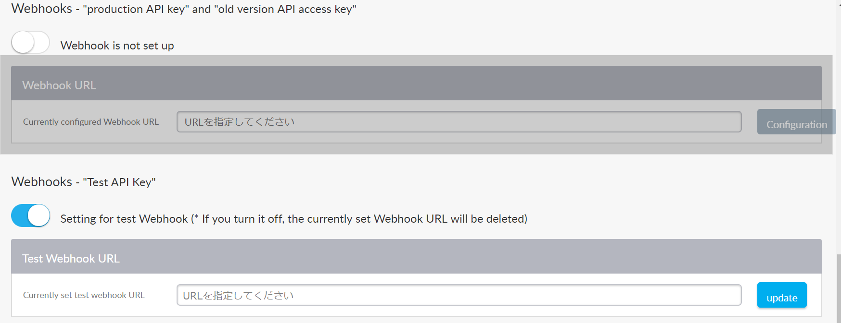

# 6. What to do when the service is down

・what happens when the service is down

If you select Paidy payment, you will get an error screen or the pop-up will stop working.

・what the merchant should do to fix it

To get started, please contact Paidy Technical Support.

Paidy Technical Support

Mail: tech-support@paidy.com

TEL : 03-5545-5099 (weekdays 10:00-18:00)

If it takes a time to recover, please set the enable flag for paidy\_enabled to "いいえ(No)" in the Custom Preferences.

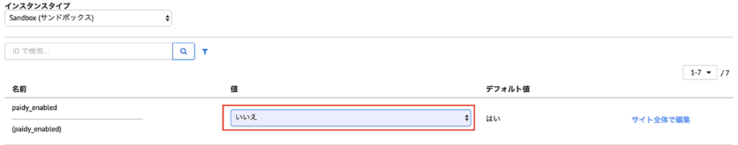

# 7. Revision history

|  |  |  |
| --- | --- | --- |
| Version | Date | Revisions |
| 17.10.0 | 2017/10/13 | First edition |
| 18.01.0 | 2018/01/09 | - Revised steps to account for developing cartridges with JSController and use on both Pipeline sites and JSController sites  - Revisions pursuant to deprecated Webhook on Commerce Cloud  Added 5. Operational examples |
| 19.01.0 | 2019/10/25 | -Correct meta information file and update usage procedure.  -The function “ServiceRegistry” used in JScontroller is abolished and “LocalServiceRegistry” is used.  -Implement "getResponseLogMessage" in the service process called by JScontroller.  -All HTTPClient calls now support service usage.  -Add DocComment to each function. |
| 20.1.0 | 2020/01/15 | 3-2-2. Importing metadata  -Modify 「meta\_data\_19.1.0.zip」to「meta\_data\_20.1.0.zip」 |
| 20.1.0 | 2020/4/5 | - The following changes were made due to the file name change 3-3-1. CheckoutJS installation  before： <script src="${URLUtils.staticURL('js/paidy\_normal.js')}"></script> <script src="${URLUtils.staticURL('js/paidy\_regular.js')}"></script> after： <script src="${URLUtils.staticURL('js/paidyNormal.js')}"></script>  <script src="${URLUtils.staticURL('js/paidyRegular.js')}"></script>  -Add 6. What to do when the service is down  - Removed references to the Pipeline site. |
| 21.1.0 | 2021/6/21 | -Update 1. Cartridges version update  -Update 15. Changes: Changed "meta\_data\_20.1.0.zip" to "meta\_data\_21.1.0\_sg.zip" |
| 22.1.0 | 2022/6/21 | p.1  update version in cover  all pages  Modified normal payment ID andsubscription ID, as follows.   * normal -> standard * regular -> subscription   p.4  updated supported store Front Reference Architecture and compatibility mode version  p.17  update import meta file name  p.37  4-3. Removed IE11 from Browser compatibility |
| 22.1.1 | 2022/11/24 | All pages  The following modifications were made due to the change in the name of Paidy standard and subscription payment service.  ● standard payment  あと払い (ペイディ)  ● subscription payment  あと払い (ペイディ) ※定期購入  ●支払方法説明  ・クレジットカード、事前登録不要。  ・メールアドレスと携帯番号だけで、今すぐお買い物。  ・1か月に何度お買い物しても、お支払いは翌月まとめて1回でOK。  ・お支払いは翌月10日までに、コンビニ払い・銀行振込・口座振替で。  ペイディについて詳しくはこちら。  Capture was changed to reflect the above changes. |